**Project Report**

**on**

**“WEB SITE FOR SPN E-BIKES In**

**HTML**

**Submitted to,**

**SHIVAJI UNIVERSITY, KOLHAPUR**

**In the partial fulfillment**

**of award of degree**

**Bachelor of Computer Application**

**(BCA-II) (Sem-IV)**

**SUBMITTED BY,**

**Mr. Safwan Vahid Inamdar**

**Roll number: 6**

**Mr.Nadim faruk Devale**

**Roll number: 5**

**Mr. Padmbhushan Gajanan Mane**

**Roll number: 10**

**Under the Valuable Guidance of**

**Miss. P. R. Jadhav**



**Karmaveer Bhaurao Patil College,Urun-Islampur,**

**Tal:-Walwa, Dist:-Sangli**

**Year:-2021-2022**



**CERTIFICATE OF APPROVAL**

This is to certify that, **Mr.Safwan Vahid Inamdar, Mr.Nadim Faruk devale,Mr. Padmbhushan Gajanan Mane** have submitted their project report entitled **“Web Site ForSPN E-BIKES”** has been successfully completed for the partial fulfillment of the **Bachelor of Computer Application (BCA-II) (Sem-IV)** as prescribed by the Shivaji University, Kolhapur. To the best of our knowledge and belief, matter presented in this project report has not been submitted earlier and it is their original work.

|  |  |  |  |
| --- | --- | --- | --- |
| Miss, P. R. Jadhav  Guide | | Mr./ Miss. ……..  HOD | |
| External Examiner |  | | Principal  Karmaveer Bhaurao Patil College  Urun-Islampur |

**DECLARATION**

To,

The Principal,

Karmaveer Bhaurao Patil College,Urun-Islampur

Respected sir,

We undersigned hereby declare that, the project report entitled “Web Site for SPN E-BIKES” is developed for and submitted by us under the guidance of Miss. P.R. Jadhav is our original work.

The empirical finding in this report is based on the information collected by us. We have not copied any matter from any report. This work is humbly submitted to Shivaji University, Kolhapur for the award of Bachelor of Computer Application (B.C.A) by us.

Thanking you,

Mr.Safwan Vahid Inamdar

Mr.Nadim Faruk Devale

Mr.Padmbhushan Gajanan Mane

Place: Islampur

Date: / /2022.

**ACKNOWLEDGEMENT**

This is our great pleasure in submitting this project entitled “Web Site for SPN E-BIKES” to Shivaji University, Kolhapur. We are very sincerely expressing our thanks to Principal Dr.A.B.Patil for providing we required facilities to complete this project. We also thanks to Prof S.B.Patil Head of the Computer Science department who encouraged us.

We are thankful to our guide Miss.P.R.Jadhav for valuable Guidance and kind help during completion of our project report.

We are hearty thanks to all of them who helped me directly or indirectly to complete this project smoothly.

Thanks to all

Mr. Safwan Vahid Inamdar

Mr. Nadim Faruk Devale

Mr. Padmbhushan Gajanan Mane

**Place**: Islampur.

**Date:** / /2022.

INDEX

|  |  |  |
| --- | --- | --- |
| Chapter No. | Chapter Name | Page No. |
| 1 | Introduction  a)Introduction to System  b)Advantages of System |  |
| 2 | Organization Profile  a)History of Organization  b) organizational chart |  |
| 3 | Introduction to HTML  a)Introduction to HTML  b)Features of HTML c)Advantages of HTML |  |
| 4 | System analysis Design a)Fact Finding Techniques  b)System Flow Diagram |  |
| 5 | Implementations   1. System Requirement 2. User Manual |  |
| 6 | Source Code |  |
| 7 | Output Design |  |
| 8 | Conclusion |  |
|  | Bibliography |  |

|  |
| --- |
| **Chapter 1** |
| **SPN E-BIKES** |

**A) Introduction to system-**

The electric scooters are cheap, convenient and funny means of transport you can go anywere on roads and street and enjoy making local errands fun quick and easy. You can ride the electric scooty in the corridor of your home and shopping malls. Electric scooters are cheerful way of transportation. We have created for the convenience of our customer . this allows you to get all the information about the bikes in the showroom in the simple and straightforward language and we have used HTML language to create website attractive to all the costumers.

B**) Advantages of System-**

1. Environmental friendly.
2. Lower running cost.
3. E- scooters can be convenient
4. No air pollution
5. You can save energy
6. Greenhouse gas emissions savings
7. Less voice
8. Light weight

|  |
| --- |
| **Chapter 2** |
| **SPN E-BIKES** |

**History of organization-**

It is an Electric mopeds and automobile shop located at Islampur. It is established on 02/04/2022 owned by blix and owkaya. The owner of the organization is Mr.Juned Sande

**Organizational chart-**

Owner (Dealer)

Manager

Brand promoter

Staff

Customer

|  |
| --- |
| **Chapter 3** |
| **SPN E-BIKES** |

**Introduction to HTML-**

HTML stands for Hyper Text Markup Language. Is an ordinary text that has extra features such as formatting multimedia link to other documents? Markup is the process of taking ordinary text and adding to symbol to that text such as editing reading symbols is type of markup. Each of the symbol is used for markup in HTML is command that tell the borrower how to display the text.

**Feature of HTML-**

The internet is international network of computer that exchange of information with each other the World Wide Web (WWW) is a vast interconnected library of information art and commerce. The web consists of several web pages. HTML is used to build web pages. Once web page is build it can be published on internet. Publishing means transferring web page to a server so that people all over the world will be able to read it is a huge variety of pages for e.g. We have personal home pages business home pages. Directories (List of web pages), search engines and artist projects. It is universal language for classifying the function of different section of different section of a document. It is define different parts of your pages. You can indicate which part is title, which part is address, which part should be emphasized and which part should include an image and so on. HTML specifics part of your document is that browser can display it correctly.

**Advantages of HTML-**

1. It is easy to understand.
2. For creating HTML document newly only text only creates there is no requirement of special software.
3. If something is not working then finding of error is easy in HTML
4. HTML document can create an only hardware platform using text editor

|  |
| --- |
| **Chapter 4** |
| **SPN E-BIKES** |

#### Fact finding technique-

In order to gather and analyze the relevant information following method are adopted.

#### Observation-

First –hand information about various activities carried out can be studied through observation. This method is used to solve how documents where handled, how process carried out and whether those steps actually followed. Thus current scenario was understood using observation.

#### Record Review-

The study records maintained to give clear idea as to actual process carried also management working on whole.

#### Searching Document-

Various documents which are handled these used format where studied. Relation with system, information analyzed.

#### Interviews-

Timely conducting interviews of accountant where made to understand extra working of system useful in bringing us all ideas to make system effectives.

**Feasibility study-**

Feasibility study carried the workability of proposed system .So this study is as system proposed regarding this workability, impact on organization ability to meet to user need and effecting use of Resources.

Thus when new application programs if normally goes through a feasibility study and risk analysis is related in many ways. If project Risk is the great the feasibility and risk producing quality software is also reduce .This during feasibility analysis of project following issues of interested was required to be considering carefully.

#### a)Technical Feasibility :

Determines whether technique needed for proposed system is available and new technique can be accessed .Whether graduation can be done easily and whether organization would buy expertise to use it.

#### b) Operational feasibility:

It covers to aspect one is technical performance and other its acceptance .Technical performance include issue such as determination whether system provide right information at right place and right time at to the organization.

#### c)Economically Feasibility:

This evolution looks at financial aspects of project cost benefit analysis for common for evolution of financial effectiveness of system if the hardware, software needed for the new system is already available no extra investment incurred in that direction only cost involved in that will be that of implementing system economically feasible.

1. **System data flow chart-**

Feedback

Contact us us

Products 

Gallery

About us

Home

BLIX

Images

Establishment

Image

OWKAYA

Owner

Shop Logo

|  |
| --- |
| **Chapter 5** |
| **SPN E-BIKES** |

hen we run the project the main page open in this page.We can see this option Home, About Us, Contact Us, Feedbak.

* **Home** -Home page shows the below given option .
* **About Us** - About Us page display information about the SPN E-BIKES
* **Contact Us** -Contact Us page display the phone no. and addres for reference.
* **Feedback** -Page is the of help of user and they can place their comments.

|  |
| --- |
| **Chapter 6** |
| **SPN E-BIKES** |

**HOME-**

<html>

<head>

<style>

body{

background-image:url("pqr.jpg");

background-image:opacity-0.4;

background-image:filter-alpha(opacity=40);

}

ul {

list-style-type: none;

margin: 0;

padding: 0;

overflow: hidden;

background-color: white;

}

li {

float: left;

}

li a, .dropbtn {

display: inline-block;

color: black;

text-align: center;

padding: 14px 16px;

text-decoration: none;

}

li a:hover, .dropdown:hover .dropbtn {

background-color: red;

}

li.dropdown {

display: inline-block;

}

.dropdown-content {

display: none;

position: absolute;

background-color: #f9f9f9;

min-width: 160px;

box-shadow: 0px 8px 16px 0px rgba(0,0,0,0.2);

z-index: 1;

}

.dropdown-content a {

color: black;

padding: 12px 16px;

text-decoration: none;

display: block;

text-align: left;

}

.dropdown-content a:hover {background-color: #f1f1f1}

.dropdown:hover .dropdown-content {

display: block;

}

div{

border:none;

margin-top:100;

margin-bottom:100;

margin-left:200;

margin-right:200;

}

</style>

</head>

<body>

<ul>

<li><a href="1 Home.html">HOME</a></li>

<li><a href="___RIDE___.html">PRODUCTS</a></li>

<li><a href="About us.html">ABOUT US</a></li>

<li><a href="CONTACT US.html">CONTACT US</a></li>

<li><a href="FEEDBACK.html">FEEDBACK</a></li>

</ul>

<div>

<h1>

<font color="white" size="50%">

<center>

SPN E-BIKES <br></font>

</center>

<center>

<font color="red">

FIND YOUR PERFECT BIKE<br>

</h1></center>

<h3>

</font>

<B><font color="white">

<center>

we have more than a thousand bikes<br>

for you to choice.

</h3></center>

</font>

</div>

</body>

</html>

**PRODUCT-**

<html>

<head>

<style>

div{

background-color:BLACK;

}

</style>

</head>

<H5><b>

<a href="1 Home.html">HOME</a>&nbsp&nbsp&nbsp

<a href="___RIDE___.html">PRODUCTS</a>&nbsp&nbsp&nbsp

<a href="About us.html">ABOUT US</a>&nbsp&nbsp&nbsp

<a href="CONTACT US.html">CONTACT US</a>&nbsp&nbsp&nbsp

<a href="FEEDBACK.html">FEEDBACK</a>

</font>

<body bgcolor=" silver">

<center>

<div>

<img src="bike 11.png" height="15%" width="10%">

<font face="Stencil"color="WHITE" size="18">

<i><u> SPN E-BIKES</u></i>

</font>

<img src="bike 10.png"height="15%" width="10%"></h1>

</div>

<hr color="red">

</center>

<h1><b><a href="1 Home.html"><font size="5">HOME</font></a>

&nbsp&nbsp&nbsp&nbsp&nbsp&nbsp&nbsp&nbsp&nbsp&nbsp&nbsp&nbsp&nbsp&nbsp

&nbsp&nbsp&nbsp&nbsp&nbsp&nbsp&nbsp&nbsp&nbsp&nbsp&nbsp&nbsp&nbsp&nbsp

&nbsp&nbsp&nbsp&nbsp&nbsp&nbsp&nbsp&nbsp&nbsp&nbsp&nbsp

&nbsp&nbsp&nbsp&nbsp&nbsp&nbsp&nbsp&nbsp&nbsp&nbsp&nbsp

&nbsp&nbsp&nbsp&nbsp&nbsp&nbsp&nbsp&nbsp&nbsp&nbsp&nbsp&nbsp&nbsp

<a href="model 1.html"><font size="5" color="purple"> MODEL'S

</font></h1></b>

</a>

<center>

<img src="spn bike 3.png" height="55%" width=" 90%">

<font face="Lucida Bright" size="5" color="black">

<b>

<br> <u>Enjoy the ride!!!</u><br>

_____Choose form India's largest e-bike range_____

</b>

</font>

<hr size="2" color="red">

<marquee bgcolor="BLACK" >

<font face="Cambria Math" color ="white"size="5">

Contact Us :-

Mr.Safwan Inamdar :- 7559244647, Mr.Padmbhushan Mane :- 8408065816 , Mr.Nadim Devle :- 8421844224,

Email ID :- SPN E-BIKES99@gmail.com ,

www. spn e-bikes.com

</marquee>

</font>

<hr size="2" color="red">

</center>

</body>

</html>

**MODEL’S-**

<html>

<head>

<style>

div{

background-color:BLACK;

}

</style>

</head>

<body bgcolor="SILVER">

<center><h1>

<Div>

<img src="bike 11.png" height="15%" width="10%"> <font face="Stencil"color="WHITE" size="18">

<i><b><u>SPN E-BIKES</u></b></i>

</img><img src="bike 10.png"height="15%" width="10%"></img></h1></center>

</div></h1>

<h3>

</font>

<a href="1 Home.html">Home</a>&nbsp&nbsp&nbsp&nbsp&nbsp&nbsp&nbsp&nbsp <a href="___RIDE___.html">MODEL'S</a>

<hr size="4" color="BLACK"></h3>

<font face="Modern No. 20" size="6">

<B>&nbsp&nbsp&nbsp&nbsp&nbsp&nbsp&nbsp&nbsp&nbsp&nbsp&nbsp&nbsp&nbsp&nbsp

MODEL NO.1&nbsp&nbsp&nbsp&nbsp&nbsp&nbsp&nbsp&nbsp&nbsp&nbsp&nbsp&nbsp&nbsp&nbsp&nbsp&nbsp&nbsp&nbsp&nbsp&nbsp&nbsp&nbsp&nbsp&nbsp&nbsp

&nbsp&nbsp MODEL NO.2&nbsp&nbsp&nbsp&nbsp&nbsp&nbsp&nbsp&nbsp&nbsp&nbsp&nbsp&nbsp&nbsp&nbsp&nbsp&nbsp&nbsp&nbsp&nbsp&nbsp&nbsp&nbsp&nbsp&nbsp&nbsp

&nbsp&nbsp&nbsp&nbspMODEL NO.3

</font></B>

<br>

&nbsp&nbsp&nbsp&nbsp&nbsp&nbsp&nbsp&nbsp&nbsp&nbsp&nbsp&nbsp&nbsp&nbsp&nbsp&nbsp

&nbsp&nbsp&nbsp&nbsp&nbsp&nbsp&nbsp&nbsp

<img src="M1.png" height="20%" width="15%">

&nbsp&nbsp&nbsp&nbsp&nbsp&nbsp&nbsp&nbsp&nbsp&nbsp&nbsp&nbsp

&nbsp&nbsp&nbsp&nbsp&nbsp&nbsp&nbsp&nbsp&nbsp&nbsp&nbsp&nbsp&nbsp

&nbsp&nbsp&nbsp&nbsp&nbsp&nbsp&nbsp&nbsp&nbsp&nbsp&nbsp&nbsp&nbsp&nbsp&nbsp

&nbsp&nbsp&nbsp&nbsp&nbsp&nbsp&nbsp&nbsp&nbsp&nbsp&nbsp&nbsp&nbsp&nbsp

<img src="mm2.png" height="20%" width="15%">

&nbsp&nbsp&nbsp&nbsp&nbsp&nbsp&nbsp&nbsp&nbsp&nbsp&nbsp&nbsp

&nbsp&nbsp&nbsp&nbsp&nbsp&nbsp&nbsp&nbsp&nbsp&nbsp&nbsp&nbsp&nbsp&nbsp&nbsp

&nbsp&nbsp&nbsp&nbsp&nbsp&nbsp&nbsp&nbsp&nbsp&nbsp&nbsp&nbsp&nbsp&nbsp

&nbsp&nbsp&nbsp&nbsp&nbsp&nbsp&nbsp&nbsp&nbsp&nbsp&nbsp&nbsp

<img src="mmm1.jpg" height="20%" width="15%">

<font face="Centaur" size="5"><b>

<hr size="5" color="black">

<br>

&nbsp&nbsp&nbsp&nbsp&nbsp&nbsp&nbsp&nbsp&nbsp

&nbsp&nbsp&nbsp&nbsp&nbsp&nbsp&nbsp&nbsp

Company :- Blix, Okaya

&nbsp&nbsp&nbsp&nbsp&nbsp&nbsp&nbsp&nbsp&nbsp

&nbsp&nbsp&nbsp&nbsp&nbsp&nbsp&nbsp&nbsp&nbsp&nbsp

&nbsp&nbsp&nbsp&nbsp&nbsp&nbsp&nbsp&nbsp&nbsp&nbsp&nbsp&nbsp

Company :- Blix, Okaya

&nbsp&nbsp&nbsp&nbsp&nbsp&nbsp&nbsp&nbsp&nbsp&nbsp&nbsp

&nbsp&nbsp&nbsp&nbsp&nbsp&nbsp

&nbsp&nbsp&nbsp&nbsp&nbsp&nbsp&nbsp&nbsp&nbsp&nbsp&nbsp&nbsp

&nbsp&nbsp&nbsp&nbsp&nbsp&nbsp

Company :- Blix, Okaya

<br>

&nbsp&nbsp&nbsp&nbsp&nbsp&nbsp&nbsp&nbsp&nbsp&nbsp&nbsp&nbsp

&nbsp&nbsp&nbsp&nbsp&nbsp&nbsp&nbsp&nbsp

Bike Name :- Glob

&nbsp&nbsp&nbsp&nbsp&nbsp&nbsp&nbsp&nbsp&nbsp&nbsp&nbsp&nbsp&nbsp&nbsp&nbsp&nbsp

&nbsp&nbsp&nbsp&nbsp&nbsp&nbsp&nbsp&nbsp&nbsp

&nbsp&nbsp&nbsp&nbsp&nbsp&nbsp&nbsp&nbsp&nbsp

&nbsp

Bike Name :- Wolf Plus

&nbsp&nbsp&nbsp&nbsp&nbsp&nbsp&nbsp&nbsp&nbsp&nbsp&nbsp&nbsp&nbsp

&nbsp&nbsp&nbsp&nbsp&nbsp&nbsp&nbsp&nbsp&nbsp

&nbsp&nbsp&nbsp&nbsp&nbsp&nbsp&nbsp&nbsp&nbsp&nbsp&nbsp&nbsp

&nbsp

Bike Name :- Gen Nxt

<br>

&nbsp&nbsp&nbsp&nbsp&nbsp&nbsp&nbsp&nbsp&nbsp&nbsp&nbsp&nbsp

&nbsp&nbsp&nbsp&nbsp&nbsp&nbsp&nbsp&nbsp

Charging :- 2.5hr&nbsp&nbsp&nbsp&nbsp&nbsp&nbsp&nbsp&nbsp&nbsp&nbsp&nbsp&nbsp

&nbsp&nbsp&nbsp&nbsp&nbsp&nbsp&nbsp&nbsp&nbsp&nbsp&nbsp&nbsp

&nbsp&nbsp&nbsp&nbsp&nbsp&nbsp

&nbsp&nbsp&nbsp&nbsp&nbsp&nbsp&nbsp&nbsp&nbsp&nbsp&nbsp&nbsp

Charging :- 2.5hr&nbsp&nbsp&nbsp&nbsp&nbsp&nbsp&nbsp&nbsp&nbsp&nbsp&nbsp&nbsp

&nbsp&nbsp&nbsp&nbsp&nbsp&nbsp&nbsp&nbsp

&nbsp&nbsp&nbsp&nbsp

&nbsp&nbsp&nbsp&nbsp&nbsp&nbsp&nbsp&nbsp&nbsp&nbsp&nbsp&nbsp&nbsp&nbsp&nbsp&nbsp&nbsp&nbsp&nbsp&nbsp&nbsp

Charging :- 2.5hr

<br>

&nbsp&nbsp&nbsp&nbsp&nbsp&nbsp&nbsp&nbsp&nbsp&nbsp&nbsp&nbsp

&nbsp&nbsp&nbsp&nbsp&nbsp&nbsp&nbsp

Price :- Rs 71,500/-

&nbsp&nbsp&nbsp&nbsp&nbsp&nbsp&nbsp&nbsp&nbsp&nbsp&nbsp&nbsp&nbsp

&nbsp&nbsp&nbsp&nbsp&nbsp&nbsp&nbsp&nbsp&nbsp&nbsp&nbsp

&nbsp&nbsp&nbsp&nbsp&nbsp&nbsp&nbsp&nbsp&nbsp&nbsp&nbsp&nbsp&nbsp

Price :- Rs 75,000/-

&nbsp&nbsp&nbsp&nbsp&nbsp&nbsp&nbsp&nbsp&nbsp&nbsp&nbsp&nbsp

&nbsp&nbsp&nbsp&nbsp&nbsp&nbsp&nbsp&nbsp&nbsp&nbsp&nbsp&nbsp

&nbsp

&nbsp&nbsp&nbsp&nbsp&nbsp&nbsp&nbsp&nbsp&nbsp&nbsp&nbsp&nbsp&nbsp&nbsp

Price :- Rs 85,500/-

<br>

<br>

&nbsp&nbsp&nbsp&nbsp&nbsp&nbsp&nbsp&nbsp&nbsp&nbsp

&nbsp&nbsp

&nbsp&nbsp&nbsp&nbsp&nbsp&nbsp&nbsp&nbsp&nbsp&nbsp

<a href ="Bike M01.html"> *COLOUR*</a>

&nbsp&nbsp&nbsp&nbsp&nbsp&nbsp&nbsp&nbsp&nbsp&nbsp&nbsp&nbsp

&nbsp&nbsp&nbsp&nbsp&nbsp&nbsp&nbsp&nbsp

&nbsp&nbsp&nbsp&nbsp&nbsp&nbsp&nbsp&nbsp&nbsp&nbsp

&nbsp&nbsp&nbsp&nbsp&nbsp&nbsp&nbsp&nbsp&nbsp&nbsp&nbsp&nbsp&nbsp&nbsp&nbsp&nbsp

<a href ="bike M02.html"> *COLOUR*</a>&nbsp&nbsp&nbsp&nbsp&nbsp&nbsp&nbsp&nbsp&nbsp&nbsp

&nbsp&nbsp&nbsp&nbsp&nbsp&nbsp&nbsp&nbsp&nbsp&nbsp&nbsp&nbsp&nbsp&nbsp&nbsp&nbsp&nbsp&nbsp

&nbsp&nbsp&nbsp&nbsp&nbsp&nbsp&nbsp&nbsp&nbsp&nbsp&nbsp&nbsp&nbsp&nbsp&nbsp&nbsp&nbsp&nbsp

&nbsp&nbsp&nbsp&nbsp&nbsp&nbsp&nbsp&nbsp

<a href ="bike M03.html"> *COLOUR*</a>

<hr size="2" color="black">

<marquee direction="left" bgcolor="black" > <font face="Cambria Math"size="5" color="blue">Contact Us :-

Mr.Safwan Inamdar :- 7559244647, Mr.Padmbhushan Mane :- 8408065816 , Mr.Nadim Devle :- 8421844224,

Email ID :- SPN E-BIKES99@gmail.com ,www.spn e-bikes.com

</marquee>

</font><hr size="2" color="black">

</b></font>

</body>

</html>

**BIKE MO1-**

<html>

<head>

<style>

div{

background-color:black;

}

</style>

</head>

<body bgcolor="silver">

<center>

<div>

<img src="bike 11.png" height="15%" width="10%"> <font face="Stencil"color="white" size="18">

<i><u>SPN E-BIKES</u></i> </font>

</img><img src="bike 10.png"height="15%" width="10%"></img></h1></center>

</div>

</center>

<br>

<a href="model 1.html">MODEL</a>

<hr size="3" color="black">

<br><br><br><br><br><br>

&nbsp&nbsp&nbsp&nbsp&nbsp&nbsp&nbsp&nbsp&nbsp&nbsp&nbsp&nbsp&nbsp

<img src="M1.png" height="20%" width="20%">&nbsp&nbsp&nbsp&nbsp&nbsp&nbsp&nbsp&nbsp&nbsp&nbsp

&nbsp&nbsp&nbsp&nbsp&nbsp&nbsp&nbsp&nbsp&nbsp&nbsp&nbsp&nbsp&nbsp&nbsp&nbsp

&nbsp&nbsp&nbsp&nbsp&nbsp&nbsp&nbsp&nbsp&nbsp&nbsp&nbsp&nbsp&nbsp&nbsp&nbsp

&nbsp&nbsp&nbsp&nbsp&nbsp

<img src="M2.png" height="20%" width="20%">&nbsp&nbsp&nbsp&nbsp&nbsp&nbsp&nbsp&nbsp&nbsp&nbsp

&nbsp&nbsp&nbsp&nbsp&nbsp&nbsp&nbsp&nbsp&nbsp&nbsp&nbsp&nbsp&nbsp&nbsp&nbsp

&nbsp&nbsp&nbsp&nbsp&nbsp&nbsp&nbsp&nbsp&nbsp&nbsp&nbsp&nbsp&nbsp&nbsp&nbsp

&nbsp&nbsp&nbsp&nbsp

<img src="M3.png" height="20%" width="20%">&nbsp&nbsp&nbsp&nbsp&nbsp&nbsp&nbsp&nbsp&nbsp&nbsp

&nbsp&nbsp&nbsp&nbsp&nbsp

<br><p>

<font face="Britannic" size="5">

&nbsp&nbsp&nbsp&nbsp

<a href="Bike-Glob colour-Red & Black.html">Bike-Glob colour-Red & Black</a>

&nbsp&nbsp&nbsp&nbsp&nbsp&nbsp&nbsp&nbsp&nbsp

&nbsp&nbsp&nbsp&nbsp&nbsp&nbsp&nbsp&nbsp

<a href="Bike-Glob colour-White & Black.html">Bike-Glob colour-White & Black</a>

&nbsp&nbsp&nbsp&nbsp&nbsp&nbsp&nbsp&nbsp&nbsp

&nbsp&nbsp&nbsp&nbsp&nbsp&nbsp&nbsp&nbsp&nbsp&nbsp&nbsp&nbsp&nbsp&nbsp&nbsp

<a href=" Bike-Glob colour-Black.html">Bike-Glob colour-Black</a>

</font><br><br><br><br><br><br><br><br><br>

<marquee direction="left" bgcolor="black" > <font face="Cambria Math"size="5" color="WHITE">Contact Us :-

Mr.Safwan Inamdar :- 7559244647, Mr.Padmbhushan Mane :- 8408065816 , Mr.Nadim Devle :- 8421844224 ,

Email ID :- SPN E-BIKES99@gmail.com ,

www. spne-bikes.com </marquee>

</head>

</html>

**Bike-Glob colour-Red & Black-**

<html>

<head>

<style>

div{

background-color:BLACK;

}

</style>

</head>

<body bgcolor="SILVER">

<center>

<div>

<img src="bike 11.png" height="15%" width="10%"> <font face="Stencil"color="WHITE" size="18">

<i><u>SPN E-BIKES</u></i> </font>

</img><img src="bike 10.png"height="15%" width="10%"></img></h1></center>

</div>

<br>

<a href="Bike M01.html">BACK</a>

</center><br><p>

<center>

<hr size="3" color="black">

<h1><b><u>*Information*</h1></b></u>

<table border="7" cellspacing="8" cellpadding="7" >

<tr>

<td><font color="red">fule type</td></font>

<td><font color="red">electric</td></font>

</tr>

<tr>

<td><font color="red">Prise</td></font>

<td><font color="red">71500</td></font>

</tr>

<tr>

<td><font color="red">moter power</td></font>

<td><font color="red">1200w</td></font>

</tr>

<tr>

<td><font color="red">range</td></font>

<td><font color="red">150km</td></font>

</tr>

<tr>

<td><font color="red">top speed</td></font>

<td><font color="red">46kmph</td></font>

</tr>

<tr>

<td><font color="red">battery type</td></font>

<td><font color="red">litium-lon</td></font>

</tr>

<tr>

<td><font color="red">kerb weight</td></font>

<td><font color="red">65kg</td></font>

</tr>

</table>

</center><br><p>

<marquee direction="left" bgcolor="black" > <font face="Cambria Math"size="5" color="WHITE">Contact Us :-

Mr.Safwan Inamdar :- 7559244647, Mr.Padmbhushan Mane :- 8408065816 , Mr.Nadim Devle :- 8421844224

Email ID :- SPN E-BIKES99@gmail.com ,

www. spne-bikes.com

</marquee>

</body>

</html>

</body>

</html>

**Bike-Glob colour-White & Black-**

<html>

<head>

<style>

div{

background-color:BLACK;

}

</style>

</head>

<body bgcolor="SILVER">

<center>

<div>

<img src="bike 11.png" height="15%" width="10%"> <font face="Stencil"color="WHITE" size="18">

<i><u>SPN E-BIKES</u></i> </font>

</img><img src="bike 10.png"height="15%" width="10%"></img></h1></center>

</div>

</center><p>

<a href="Bike M01.html">BACK</a>

<center>

<hr size="3" color="black">

<h1><b><u>*Information*</h1></b></u>

<table border="7" cellspacing="8" cellpadding="7" >

<tr>

<td><font color="red">fule type</td></font>

<td><font color="red">electric</td></font>

</tr>

<tr>

<td><font color="red">Prise</td></font>

<td><font color="red">72000</td></font>

</tr>

<tr>

<td><font color="red">moter power</td></font>

<td><font color="red">1200w</td></font>

</tr>

<tr>

<td><font color="red">range</td></font>

<td><font color="red">150km</td></font>

</tr>

<tr>

<td><font color="red">top speed</td></font>

<td><font color="red">46kmph</td></font>

</tr>

<tr>

<td><font color="red">battery type</td></font>

<td><font color="red">litium-lon</td></font>

</tr>

<tr>

<td><font color="red">kerb weight</td></font>

<td><font color="red">65kg</td></font>

</tr>

</table>

</center><br><p>

<marquee direction="left" bgcolor="black" > <font face="Cambria Math"size="5" color="WHITE">Contact Us :-

Mr.Safwan Inamdar :- 7559244647, Mr.Padmbhushan Mane :- 8408065816 , Mr.Nadim Devale :- 8421844224 ,Email ID :- SPN E-BIKES99@gmail.com ,

www. spne-bikes.com

</marquee>

</body>

</html>

</body>

</html>

**Bike-Glob colour-Black-**

<html>

<head>

<style>

div{

background-color:BLACK;

}

</style>

</head>

<body bgcolor="SILVER">

<center>

<div>

<img src="bike 11.png" height="15%" width="10%"> <font face="Stencil"color="WHITE" size="18">

<i><u>SPN E-BIKES</u></i> </font>

</img><img src="bike 10.png"height="15%" width="10%"></img></h1></center>

</div>

</center><p>

<a href="Bike M01.html">BACK</a>

<center>

<hr size="3" color="black">

<h1><b><u>*Information*</h1></b></u>

<table border="7" cellspacing="8" cellpadding="7" >

<tr>

<td><font color="red">fule type</td></font>

<td><font color="red">electric</td></font>

</tr>

<tr>

<td><font color="red">Prise</td></font>

<td><font color="red">73000</td></font>

</tr>

<tr>

<td><font color="red">moter power</td></font>

<td><font color="red">1200w</td></font>

</tr>

<tr>

<td><font color="red">range</td></font>

<td><font color="red">150km</td></font>

</tr>

<tr>

<td><font color="red">top speed</td></font>

<td><font color="red">46kmph</td></font>

</tr>

<tr>

<td><font color="red">battery type</td></font>

<td><font color="red">litium-lon</td></font>

</tr>

<tr>

<td><font color="red">kerb weight</td></font>

<td><font color="red">65kg</td></font>

</tr>

</table>

</center><br><p>

<marquee direction="left" bgcolor="black" > <font face="Cambria Math"size="5" color="WHITE">Contact Us :-

Mr.Safwan Inamdar :- 7559244647, Mr.Padmbhushan Mane :- 8408065816 , Mr.Nadim Devale :- 8421844224

,Email ID :- SPN E-BIKES99@gmail.com ,

www. spne-bikes.com </marquee>

</body>

</html>

</body>

</html>

**BIKE MO2-**

<html>

<head>

<style>

div{

background-color:BLACK;

}

</style>

</head>

<body bgcolor="SILVER">

<center>

<div>

<img src="bike 11.png" height="15%" width="10%"> <font face="Stencil"color="WHITE" size="18">

<i><u>SPN E-BIKES</u></i> </font>

</img><img src="bike 10.png"height="15%" width="10%"></img></h1></center>

</div>

</center>

<br>

<a href="model 1.html">MODEL</a>

<hr size="3" color="black">

<br><br><br><br><br>

&nbsp&nbsp&nbsp&nbsp&nbsp&nbsp&nbsp&nbsp&nbsp&nbsp&nbsp&nbsp&nbsp&nbsp

<img src="mm1.png" height="20%" width="20%">

&nbsp&nbsp&nbsp&nbsp&nbsp&nbsp&nbsp&nbsp&nbsp&nbsp&nbsp&nbsp&nbsp&nbsp&nbsp&nbsp&nbsp

&nbsp&nbsp&nbsp&nbsp&nbsp

&nbsp&nbsp&nbsp&nbsp&nbsp&nbsp&nbsp&nbsp&nbsp&nbsp&nbsp&nbsp&nbsp&nbsp&nbsp&nbsp&nbsp

&nbsp&nbsp&nbsp&nbsp&nbsp&nbsp&nbsp&nbsp&nbsp

<img src="mm.png" height="20%" width="20%">&nbsp&nbsp&nbsp&nbsp&nbsp&nbsp&nbsp&nbsp&nbsp&nbsp&nbsp&nbsp&nbsp&nbsp&nbsp

&nbsp&nbsp&nbsp&nbsp&nbsp&nbsp&nbsp

&nbsp&nbsp&nbsp&nbsp&nbsp&nbsp&nbsp&nbsp&nbsp&nbsp&nbsp&nbsp&nbsp&nbsp&nbsp&nbsp&nbsp&nbsp&nbsp

<img src="mm3.png" height="20%" width="20%">

<br><br>

<font face="Britannic" size="5">

&nbsp&nbsp&nbsp&nbsp

&nbsp

&nbsp&nbsp&nbsp&nbsp&nbsp&nbsp

<a href="Bike-wolf plus colour-Red & Black.html">colour-Red & Black</a>&nbsp&nbsp&nbsp

&nbsp&nbsp&nbsp&nbsp&nbsp&nbsp&nbsp&nbsp&nbsp&nbsp

&nbsp&nbsp&nbsp&nbsp&nbsp&nbsp&nbsp&nbsp&nbsp

&nbsp&nbsp&nbsp

&nbsp&nbsp&nbsp

&nbsp&nbsp&nbsp

<a href="Bike-wolf plus colour-White & Red.html">colour-White & Black</a>

&nbsp&nbsp&nbsp&nbsp&nbsp&nbsp&nbsp&nbsp&nbsp

&nbsp&nbsp&nbsp&nbsp

&nbsp&nbsp&nbsp&nbsp&nbsp&nbsp

&nbsp&nbsp&nbsp&nbsp&nbsp&nbsp

&nbsp&nbsp&nbsp<a href="Bike-wolf plus colour-Black-White.html">colour-Black & White</a>

</font><br><br><br><br><br><br><br><br><br><br>

<marquee direction="left" bgcolor="black" > <font face="Cambria Math"size="5" color="WHITE">Contact Us :-

Mr.Safwan Inamdar :- 7559244647, Mr.Padmbhushan Mane :- 8408065816 , Mr.Nadim Devale :- 8421844224,Email ID :- SPN E-BIKES99@gmail.com ,

www. spne-bikes.com </marquee>

</body>

</html>

</body>

</html>

**Bike-wolf plus colour-Red & Black-**

<html>

<head>

<style>

div{

background-color:BLACK;

}

</style>

</head>

<body bgcolor="SILVER">

<center>

<div>

<img src="bike 11.png" height="15%" width="10%"> <font face="Stencil"color="WHITE" size="18">

<i><u> SPN E-BIKES</u></i> </font>

</img><img src="bike 10.png"height="15%" width="10%"></img></h1></center>

</div>

</center><p>

<a href="bike M02.html">BACK</a>

<hr size="3" color="black">

<center>

<font color="black">

<h1><b><u>*Information*</h1></u></font>

<table border="7" cellspacing="8" cellpadding="7">

<tr>

<td><font color="red">fule type</td></font>

<td><font color="red">electric</td></font>

</tr>

<tr>

<td><font color="red">Prise</td></font>

<td><font color="red">75000</td></font>

</tr>

<tr>

<td><font color="red">moter power</td></font>

<td><font color="red">1200w</td></font>

</tr>

<tr>

<td><font color="red">range</td></font>

<td><font color="red">150km</td></font>

</tr>

<tr>

<td><font color="red">top speed</td></font>

<td><font color="red">46kmph</td></font>

</tr>

<tr>

<td><font color="red">battery type</td></font>

<td><font color="red">litium-lon</td></font>

</tr>

<tr>

<td><font color="red">kerb weight</td></font>

<td><font color="red">65kg</td></font>

</tr>

</table>

</center><br><p>

<marquee direction="left" bgcolor="black" > <font face="Cambria Math"size="5" color="WHITE">Contact Us :-

Mr.Safwan Inamdar :- 7559244647, Mr.Padmbhushan Mane :- 8408065816 , Mr.Nadim Devale :- 8421844224

,Email ID :-SPN E-BIKES99@gmail.com ,

www. spne-bikes.com </marquee>

</body>

</html>

</body>

</html>

**Bike-wolf plus colour-White & Red-**

<html>

<head>

<style>

div{

background-color:BLACK;

}

</style>

</head>

<body bgcolor="SILVER">

<center>

<div>

<img src="bike 11.png" height="15%" width="10%"> <font face="Stencil"color="WHITE" size="18">

<i><u>SPN E-BIKES</u></i> </font>

</img><img src="bike 10.png"height="15%" width="10%"></img></h1></center>

</div>

</center><p>

<a href="bike M02.html">BACK</a>

<center>

<hr size="3" color="black">

<h1><b><u>*Information*</h1></b></u>

<table border="7" cellspacing="8" cellpadding="7" >

<tr>

<td><font color="red">fule type</td></font>

<td><font color="red">electric</td></font>

</tr>

<tr>

<td><font color="red">Prise</td></font>

<td><font color="red">75500</td></font>

</tr>

<tr>

<td><font color="red">moter power</td></font>

<td><font color="red">1200w</td></font>

</tr>

<tr>

<td><font color="red">range</td></font>

<td><font color="red">150km</td></font>

</tr>

<tr>

<td><font color="red">top speed</td></font>

<td><font color="red">46kmph</td></font>

</tr>

<tr>

<td><font color="red">battery type</td></font>

<td><font color="red">litium-lon</td></font>

</tr>

<tr>

<td><font color="red">kerb weight</td></font>

<td><font color="red">65kg</td></font>

</tr>

</table>

</center><br><p>

<marquee direction="left" bgcolor="black" > <font face="Cambria Math"size="5" color="WHITE">Contact Us :-

Mr.Safwan Inamdar :- 7559244647, Mr.Padmbhushan Mane :- 8408065816 , Mr.Nadim Devle :- 8421844224

,Email ID :- SPN E-BIKES99@gmail.com ,

www. spne-bikes.com

</marquee>

</body>

</html>

</body>

</html>

**Bike-wolf plus colour-Black-White-**

**<html>**

**<head>**

**<style>**

**div{**

**background-color:BLACK;**

**}**

**</style>**

**</head>**

**<body bgcolor="SILVER">**

**<center>**

**<div>**

**<img src="bike 11.png" height="15%" width="10%"> <font face="Stencil"color="WHITE" size="18">**

**<i><u>SPN E-BIKES</u></i> </font>**

**</img><img src="bike 10.png"height="15%" width="10%"></img></h1></center>**

**</div>**

**</center><p>**

**<a href="bike M02.html">BACK</a>**

**<hr size="3" color="black">**

**<center>**

**<h1><b><u>*Information*</h1></b></u>**

**<table border="7" cellspacing="8" cellpadding="7" >**

**<tr>**

**<td><font color="red">fule type</td></font>**

**<td><font color="red">electric</td></font>**

**</tr>**

**<tr>**

**<td><font color="red">Prise</td></font>**

**<td><font color="red">76000</td></font>**

**</tr>**

**<tr>**

**<td><font color="red">moter power</td></font>**

**<td><font color="red">1200w</td></font>**

**</tr>**

**<tr>**

**<td><font color="red">range</td></font>**

**<td><font color="red">150km</td></font>**

**</tr>**

**<tr>**

**<td><font color="red">top speed</td></font>**

**<td><font color="red">46kmph</td></font>**

**</tr>**

**<tr>**

**<td><font color="red">battery type</td></font>**

**<td><font color="red">litium-lon</td></font>**

**</tr>**

**<tr>**

**<td><font color="red">kerb weight</td></font>**

**<td><font color="red">65kg</td></font>**

**</tr>**

**</table>**

**</center><br><p>**

**<marquee direction="left" bgcolor="black" > <font face="Cambria Math"size="5" color="WHITE">Contact Us :-**

**Mr.Safwan Inamdar :- 7559244647, Mr.Padmbhushan Mane :- 8408065816 , Mr.Nadim Devale :- 8421844224**

**,Email ID :- SPN E-BIKES99@gmail.com ,**

**www. spne-bikes.com </marquee>**

**</body>**

**</html>**

**</body>**

**</html>**

**BIKE MO3-**

**<html>**

**<head>**

**<style>**

**div{**

**background-color:BLACK;**

**}**

**</style>**

**</head>**

**<body bgcolor="SILVER">**

**<center>**

**<div>**

**<img src="bike 11.png" height="15%" width="10%"> <font face="Stencil"color="white" size="18">**

**<i><u>SPN E-BIKES</u></i> </font>**

**</img><img src="bike 10.png"height="15%" width="10%"></img></h1></center>**

**</div>**

**</center>**

**<br>**

**<a href="model 1.html">MODEL</a>**

**<hr size="3" color="black">**

**<br><br><br><br>**

**&nbsp&nbsp&nbsp&nbsp&nbsp&nbsp&nbsp&nbsp&nbsp&nbsp&nbsp&nbsp&nbsp&nbsp<img src="mmm1.jpg" height="20%" width="20%">&nbsp&nbsp&nbsp&nbsp&nbsp&nbsp&nbsp&nbsp&nbsp&nbsp**

**&nbsp&nbsp&nbsp&nbsp&nbsp&nbsp&nbsp&nbsp&nbsp&nbsp&nbsp&nbsp&nbsp&nbsp&nbsp&nbsp&nbsp&nbsp&nbsp&nbsp&nbsp&nbsp&nbsp&nbsp&nbsp&nbsp&nbsp&nbsp&nbsp&nbsp&nbsp&nbsp&nbsp&nbsp&nbsp&nbsp**

**<img src="mmm2.jpg" height="20%" width="20%">&nbsp&nbsp&nbsp&nbsp&nbsp&nbsp&nbsp&nbsp&nbsp&nbsp&nbsp&nbsp&nbsp&nbsp&nbsp&nbsp&nbsp**

**&nbsp&nbsp&nbsp&nbsp&nbsp&nbsp&nbsp&nbsp&nbsp&nbsp&nbsp&nbsp&nbsp&nbsp&nbsp&nbsp&nbsp&nbsp&nbsp&nbsp&nbsp&nbsp&nbsp&nbsp&nbsp&nbsp&nbsp&nbsp&nbsp&nbsp&nbsp&nbsp&nbsp&nbsp&nbsp&nbsp**

**<img src="mmm3.jpg" height="20%" width="20%">**

**<br>**

**<br><p>**

**<font face="Britannic" size="5">**

**&nbsp&nbsp&nbsp&nbsp**

**&nbsp&nbsp&nbsp&nbsp**

**<a href="Gen Nxt plus colour-Red & Black.html">colour-Red & Black</a>&nbsp&nbsp&nbsp**

**&nbsp&nbsp&nbsp&nbsp**

**&nbsp&nbsp&nbsp&nbsp**

**&nbsp&nbsp&nbsp&nbsp&nbsp&nbsp&nbsp&nbsp&nbsp&nbsp&nbsp&nbsp&nbsp&nbsp&nbsp**

**&nbsp&nbsp&nbsp&nbsp&nbsp&nbsp**

**<a href="Gen Nxtplus colour-White & Black.html">colour-White & Black</a>**

**&nbsp&nbsp&nbsp&nbsp&nbsp&nbsp&nbsp&nbsp&nbsp**

**&nbsp&nbsp&nbsp&nbsp&nbsp**

**&nbsp&nbsp&nbsp&nbsp&nbsp&nbsp&nbsp&nbsp&nbsp**

**&nbsp&nbsp&nbsp&nbsp&nbsp&nbsp&nbsp&nbsp&nbsp&nbsp&nbsp**

**&nbsp&nbsp&nbsp&nbsp**

**<a href="Gen Nxt plus colour-Black.html">colour-Black</a>**

**</font><br><br><br><br><br><br><br><br><br><br><br>**

**<marquee direction="left" bgcolor="black" > <font face="Cambria Math"size="5" color="WHITE">Contact Us :-**

**Mr.Safwan Inamdar :- 7559244647, Mr.Padmbhushan Mane :- 8408065816 , Mr.Nadim Devale :- 8421844224 ,Email ID :- SPN E-BIKES99@gmail.com ,**

**www. spne-bikes.com.com </marquee>**

**</body>**

**</html>**

**Gen Nxt plus colour-Red & Black**-

<html>

<head>

<style>

div{

background-color:BLACK;

}

</style>

</head>

<body bgcolor="SILVER">

<a href="bike M03.html">bike M03</a>

<center>

<div>

<img src="bike 11.png" height="15%" width="10%"> <font face="Stencil"color="WHITE" size="18">

<i><u>SPN E-BIKES</u></i> </font>

</img><img src="bike 10.png"height="15%" width="10%"></img></h1></center>

</div>

</center><br><p>

<center>

<hr size="5" color="black">

<h1><b><u>*Information*</h1></b></u>

<table border="7" cellspacing="8" cellpadding="7" >

<tr>

<td><font color="red">fule type</td></font>

<td><font color="red">electric</td></font>

</tr>

<tr>

<td><font color="red">Prise</td></font>

<td><font color="red">76000</td></font>

</tr>

<tr>

<td><font color="red">moter power</td></font>

<td><font color="red">1200w</td></font>

</tr>

<tr>

<td><font color="red">range</td></font>

<td><font color="red">150km</td></font>

</tr>

<tr>

<td><font color="red">top speed</td></font>

<td><font color="red">46kmph</td></font>

</tr>

<tr>

<td><font color="red">battery type</td></font>

<td><font color="red">litium-lon</td></font>

</tr>

<tr>

<td><font color="red">kerb weight</td></font>

<td><font color="red">65kg</td></font>

</tr>

</table>

</center><br><p>

<marquee direction="left" bgcolor="black" > <font face="Cambria Math"size="5" color="WHITE">Contact Us :-

Mr.Safwan Inamdar :- 7559244647, Mr.Padmbhushan Mane :- 8408065816 , Mr.Nadim Devle :- 8421844224

Email ID : SPN E-BIKES99@gmail.com ,

www. spne-bikes.com</marquee>

</body>

</html>

</body>

</html>

**Gen Nxt plus colour-Black-**

<html>

<head>

<style>

div{

background-color:BLACK;

}

</style>

</head>

<body bgcolor="SILVER">

<a href="bike M03.html">bike M03</a>

<center>

<div>

<img src="bike 11.png" height="15%" width="10%"> <font face="Stencil"color="WHITE" size="18">

<i><u>SPN E-BIKES</u></i> </font>

</img><img src="bike 10.png"height="15%" width="10%"></img></h1></center>

</div>

</center><br><p>

<center>

<hr size="5" color="black">

<h1><b><u>*Information*</h1></b></u>

<table border="7" cellspacing="8" cellpadding="7" >

<tr>

<td><font color="red">fule type</td></font>

<td><font color="red">electric</td></font>

</tr>

<tr>

<td><font color="red">Prise</td></font>

<td><font color="red">76000</td></font>

</tr>

<tr>

<td><font color="red">moter power</td></font>

<td><font color="red">1200w</td></font>

</tr>

<tr>

<td><font color="red">range</td></font>

<td><font color="red">150km</td></font>

</tr>

<tr>

<td><font color="red">top speed</td></font>

<td><font color="red">46kmph</td></font>

</tr>

<tr>

<td><font color="red">battery type</td></font>

<td><font color="red">litium-lon</td></font>

</tr>

<tr>

<td><font color="red">kerb weight</td></font>

<td><font color="red">65kg</td></font>

</tr>

</table>

</center><br><p>

<marquee direction="left" bgcolor="black" > <font face="Cambria Math"size="5" color="WHITE">Contact Us :-

Mr.Safwan Inamdar :- 7559244647, Mr.Padmbhushan Mane :- 8408065816 , Mr.Nadim Devle :- 8421844224

,Email ID :- SPN E-BIKES99@gmail.com ,

www. spne-bikes.com </marquee>

</body>

</html>

</body>

</html>

**ABOUT US-**

<!doctype html>

<html>

<head>

<link rel="stylesheet" href="style.css">

</head>

<H2><b>

<a href="1 Home.html">HOME</a>&nbsp&nbsp&nbsp

<a href="___RIDE___.html">PRODUCTS</a>&nbsp&nbsp&nbsp

<a href="About us.html">ABOUT US</a>&nbsp&nbsp&nbsp

<a href="CONTACT US.html">CONTACT US</a>&nbsp&nbsp&nbsp

<a href="FEEDBACK.html">FEEDBACK</a>

<body>

<h1>About Us</h1>

<P><br>

Company Name- SPN E-BIKES<br></P>

<P><B>Address:-</B>

GAT NO 2253,Islampur - Sangli Rd,<br>

opposite to HP PETROL PUMP<br>

Urun-Islampur<br>

Maharshtra415409.</P>

</body>

</html>

**CONTACT US-**

**<html>**

**<head>**

**<style>**

**body{**

**background-image:url("images.jpg");**

**background-position: center;**

**background-size: cover;**

**}**

**.menu a{**

**float:left;**

**display:block;**

**color:Black;**

**text-align:center;**

**padding:20px 20px;**

**}**

**</style>**

**</head>**

**<body>**

**<H5><b>**

**<a href="1 Home.html">HOME</a>&nbsp&nbsp&nbsp**

**<a href="___RIDE___.html">PRODUCTS</a>&nbsp&nbsp&nbsp**

**<a href="About us.html">ABOUT US</a>&nbsp&nbsp&nbsp**

**<a href="CONTACT US.html">CONTACT US</a>&nbsp&nbsp&nbsp**

**<a href="FEEDBACK.html">FEEDBACK</a>**

**</font>**

**</div></h2><b/><br><br>**

**</h2>**

**<h1 style="color:red;margin-left:500px;"><font size="200%">CONTACT US</h1></font>**

**<center><b><br>**

**<p style=color:White;><font size="5%">Thank you for visiting our website SPN E-BIKES </br>**

**we provide the best services and we assured that you will get best service here.</br>**

**use the following social media platform to connect with us.....</p></font>**

**<br><br><br><br><br><br><br>**

**<img src="1.jpg" height="4%" width="3%">&nbsp&nbsp&nbsp&nbsp&nbsp&nbsp&nbsp&nbsp&nbsp&nbsp&nbsp&nbsp**

**<img src="2.jpg" height="4%" width="3%">&nbsp&nbsp&nbsp&nbsp&nbsp&nbsp&nbsp&nbsp&nbsp&nbsp&nbsp&nbsp**

**<img src="4.jpg" height="4%" width="3%">&nbsp&nbsp&nbsp&nbsp&nbsp&nbsp&nbsp&nbsp&nbsp&nbsp&nbsp&nbsp**

**<img src="3.png" height="4%" width="3%"><br>**

**<br><br><br><br>**

**<p style=color:white;>**

**please conact us on <br>**

**helpline no:3768046878<br>**

**Mr.Safwan Inamdar :- 7559244647<br>**

**Mr.Padmbhushan Mane :- 8408065816<br>**

**Mr.Nadim Devle :- 8421844224**

**</body>**

**</html>**

**FEEDBACK-**

**<!doctype html>**

**<html>**

**<head>**

**<link rel="stylesheet" href="s1.css">**

**</head>**

**<style>**

**body{**

**background-image:url("wp6020417.jpg");**

**backgroung-repeat:no-repeat;**

**background-position: center;**

**background-size:cover;**

**}**

**.menu a{**

**float:left;**

**display:block;**

**color:Black;**

**text-align:center;**

**padding:20px 20px;**

**}**

**.title{**

**font-size:20px;**

**margin-right:60px;**

**}**

**.container{**

**margin-left:100px;**

**</style>**

**</head>**

**<div class=title>**

**<a href="1 Home.html">HOME</a>&nbsp&nbsp&nbsp**

**<a href="___RIDE___.html">PRODUCTS</a>&nbsp&nbsp&nbsp**

**<a href="About us.html">ABOUT US</a>&nbsp&nbsp&nbsp**

**<a href="CONTACT US.html">CONTACT US</a>&nbsp&nbsp&nbsp**

**<a href="FEEDBACK.html">FEEDBACK</a>**

**<br>**

**<br>**

**<br>**

**<body>**

**<div class="container">**

**<form>**

**<h1>Give Your Feedback</h1>**

**<div class="id">**

**<input type="text" placeholder="full name">**

**<i class="far fa-user"></i>**

**</div>**

**<div class="id">**

**<input type="text" placeholder="email id"**

**<i class="far fa-user"></i>**

**</div>**

**<textarea cols="15" rows="5" placeholder="Enetr your opinion here..."></textarea>**

**<button>send</button>**

**</body>**

**</html>**

|  |
| --- |
| **Chapter 7** |
| |  | | --- | | **SPN E-BIKES** | |

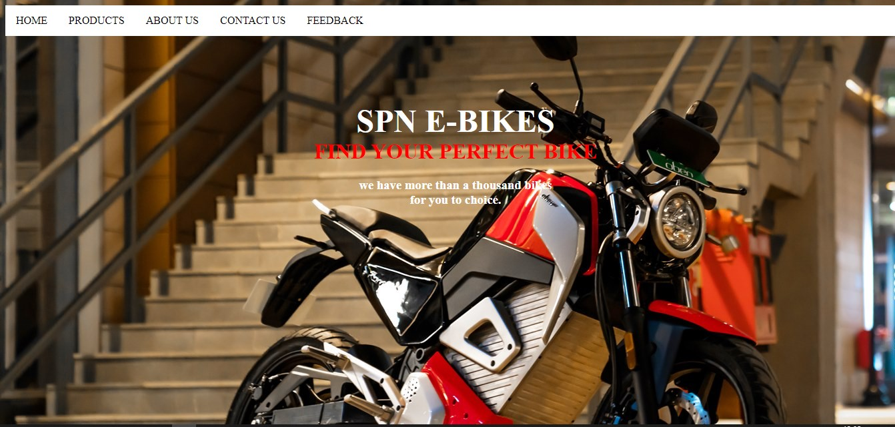

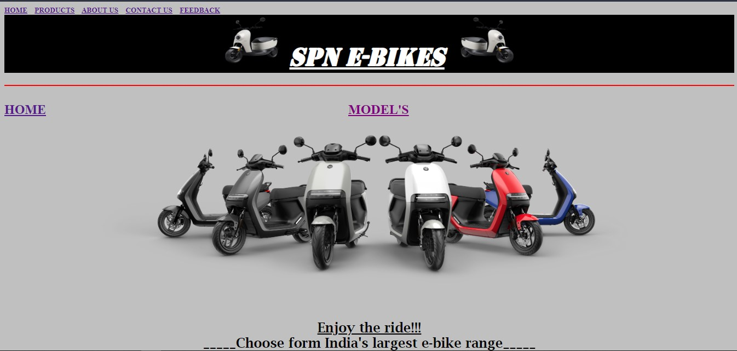

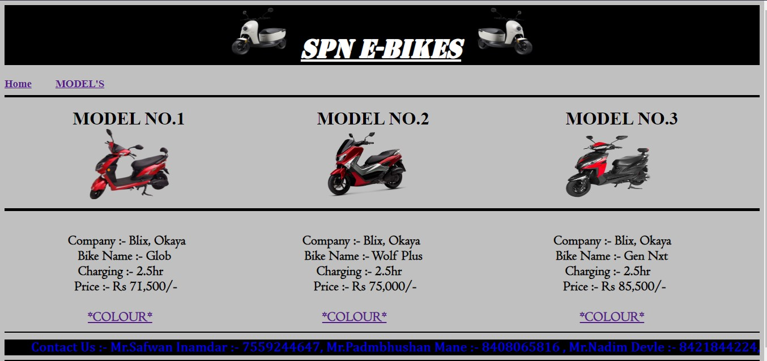

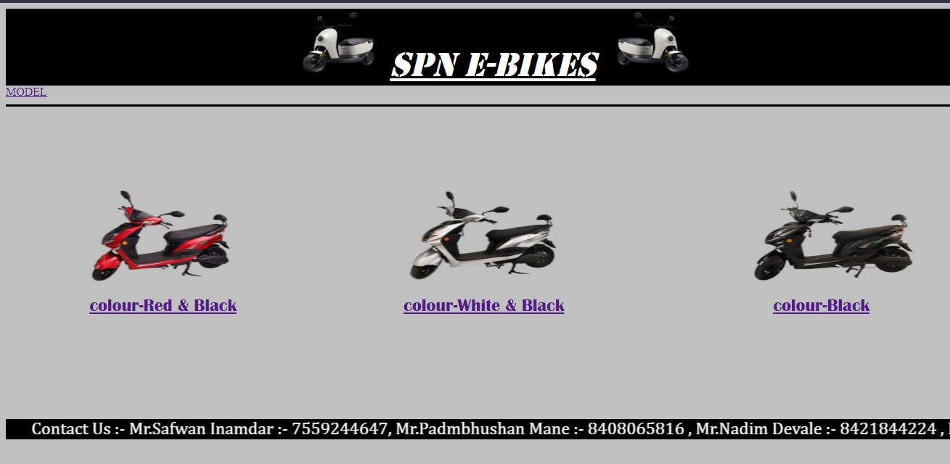

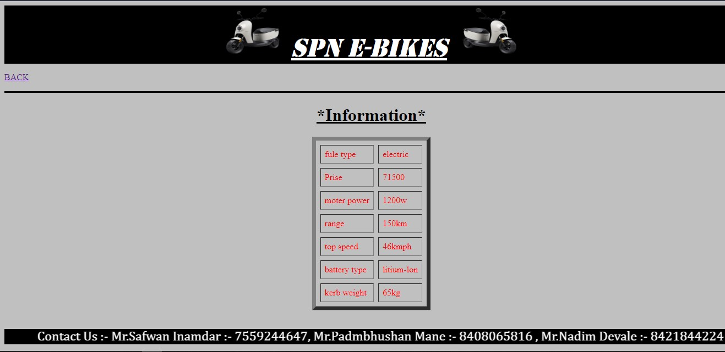

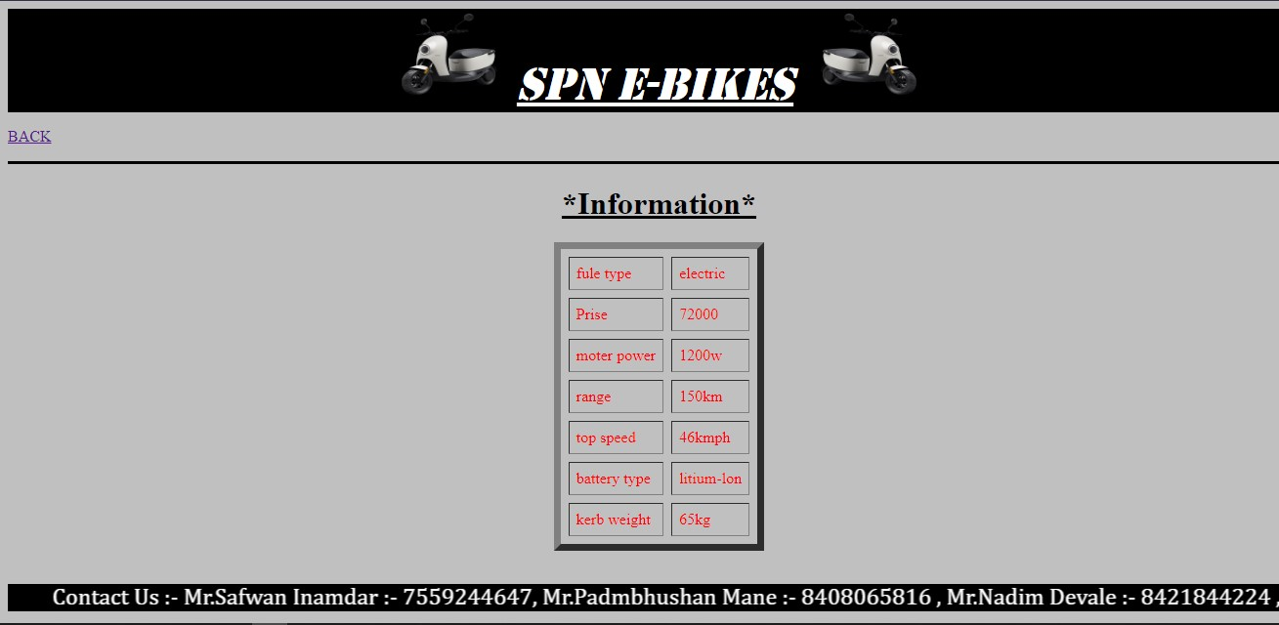

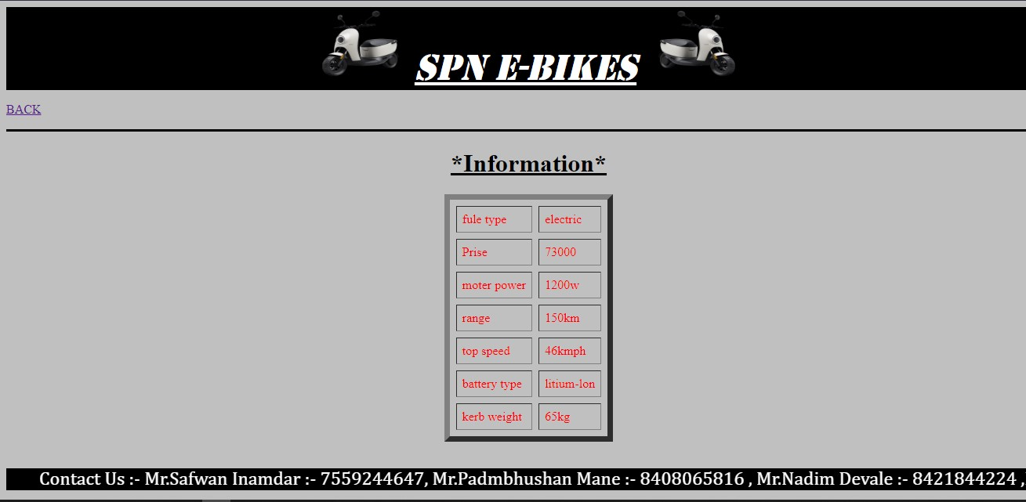

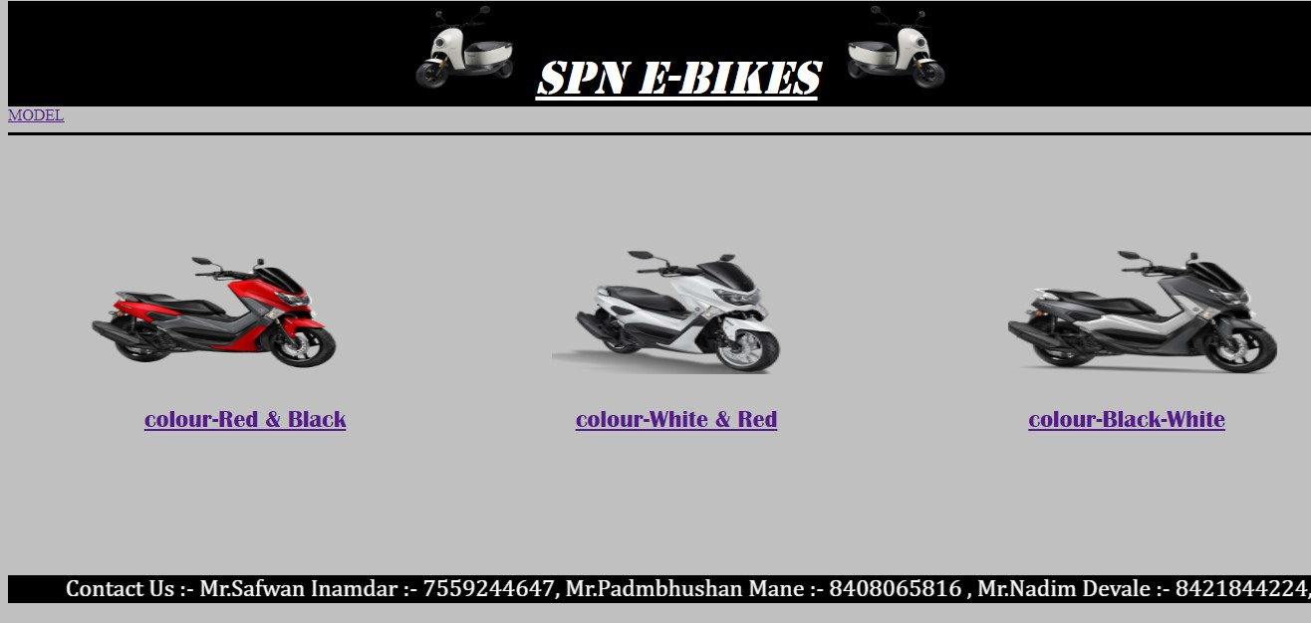

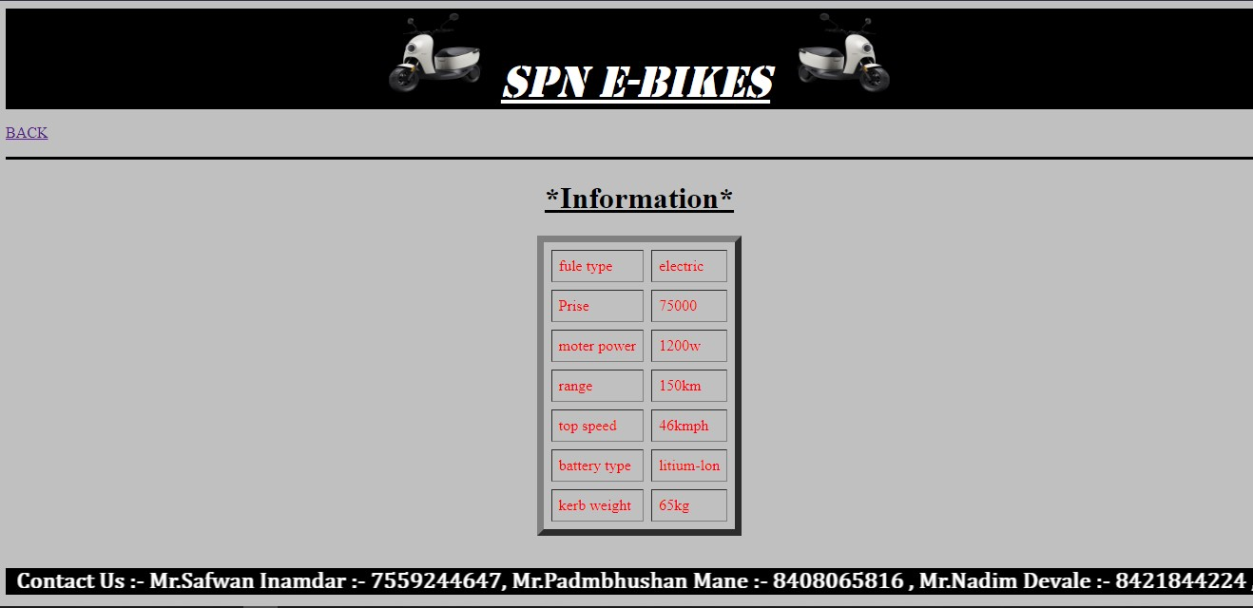

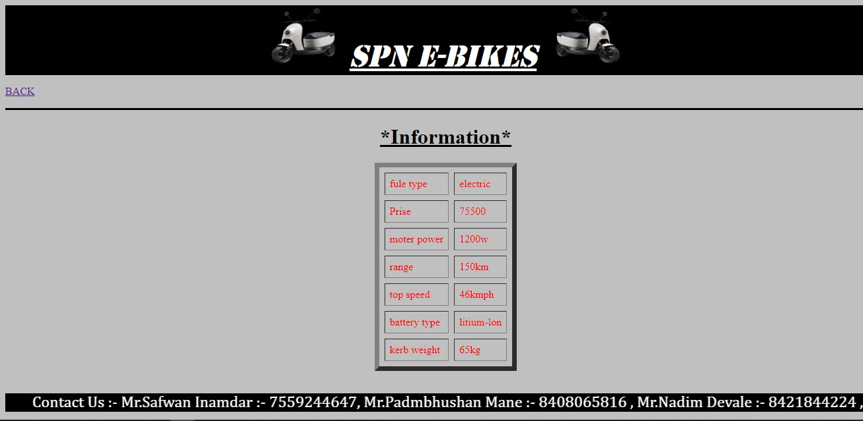

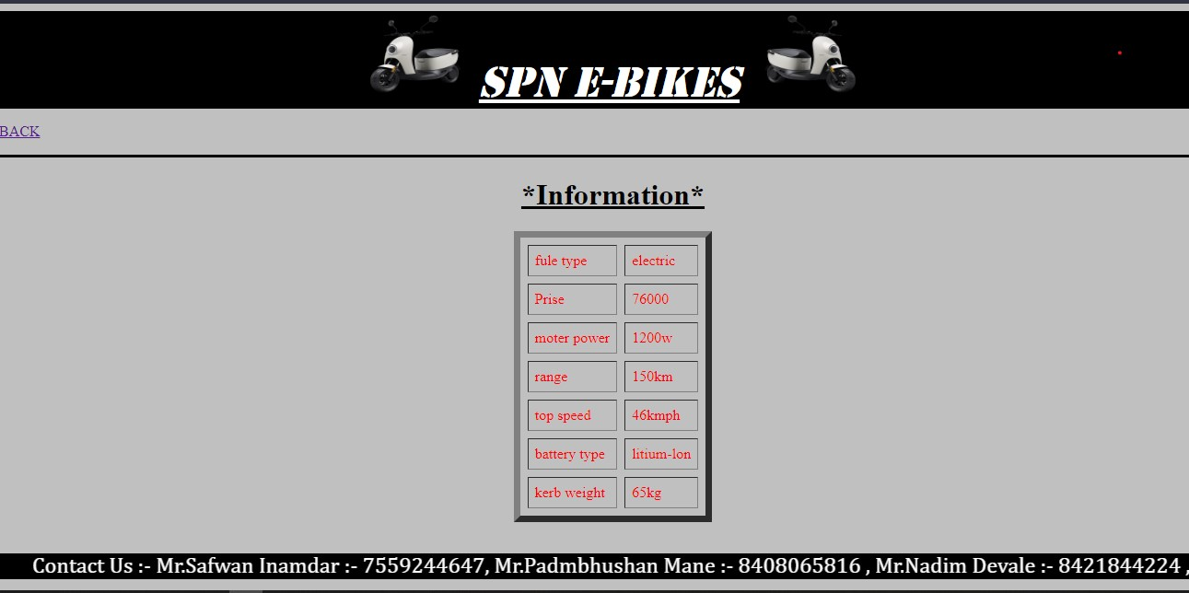

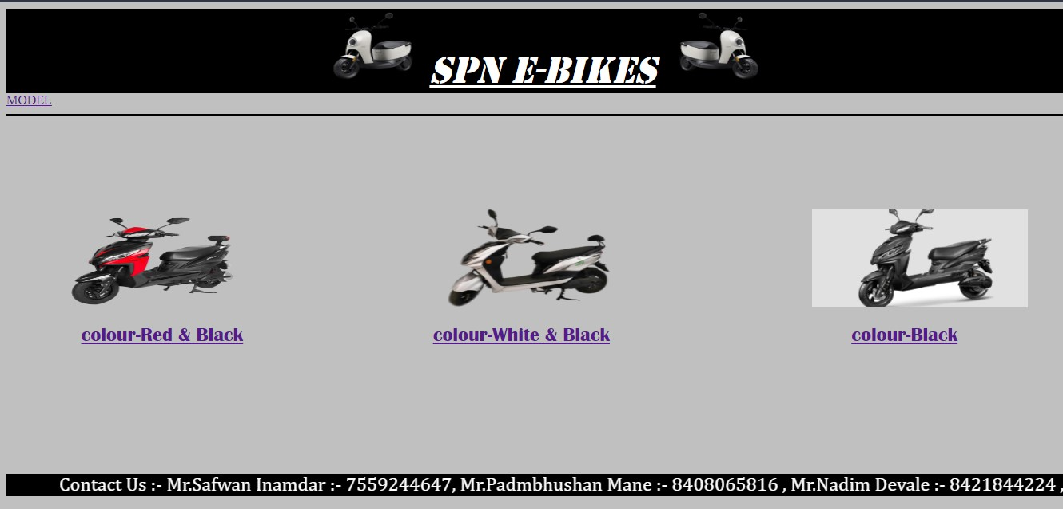

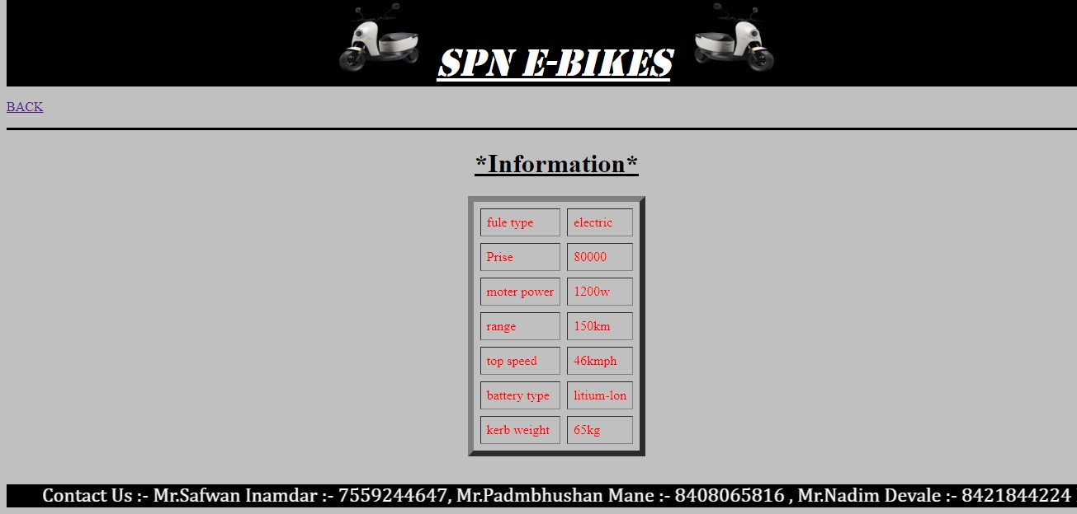

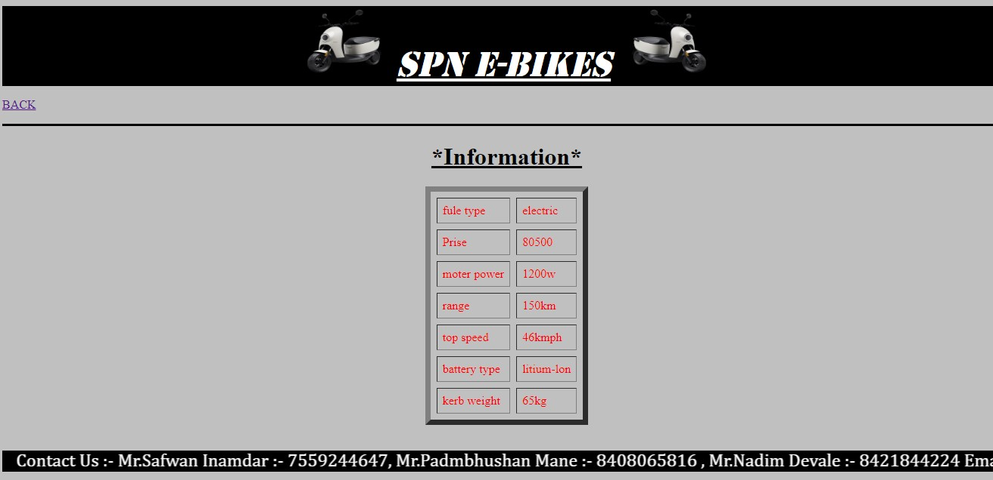

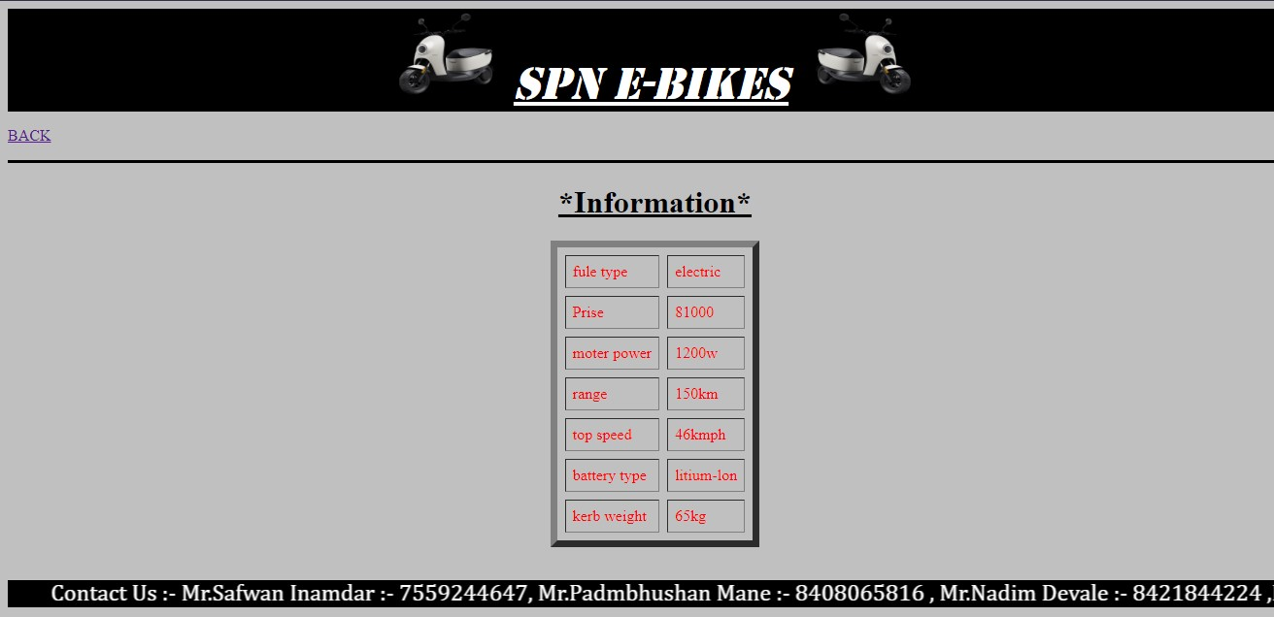

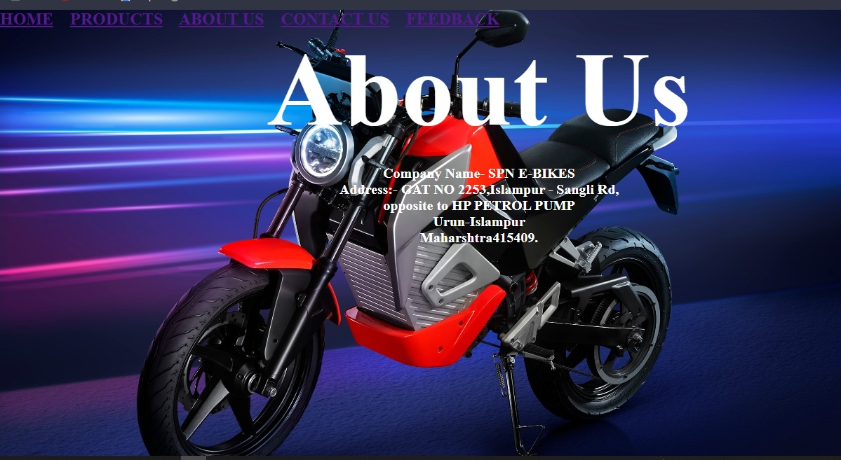

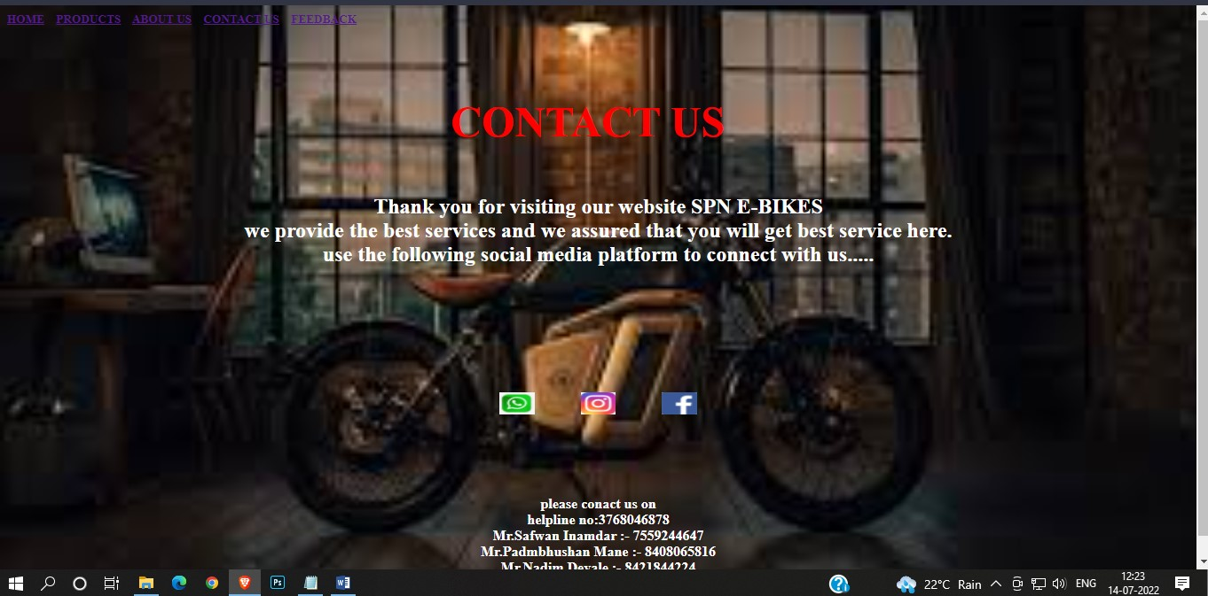

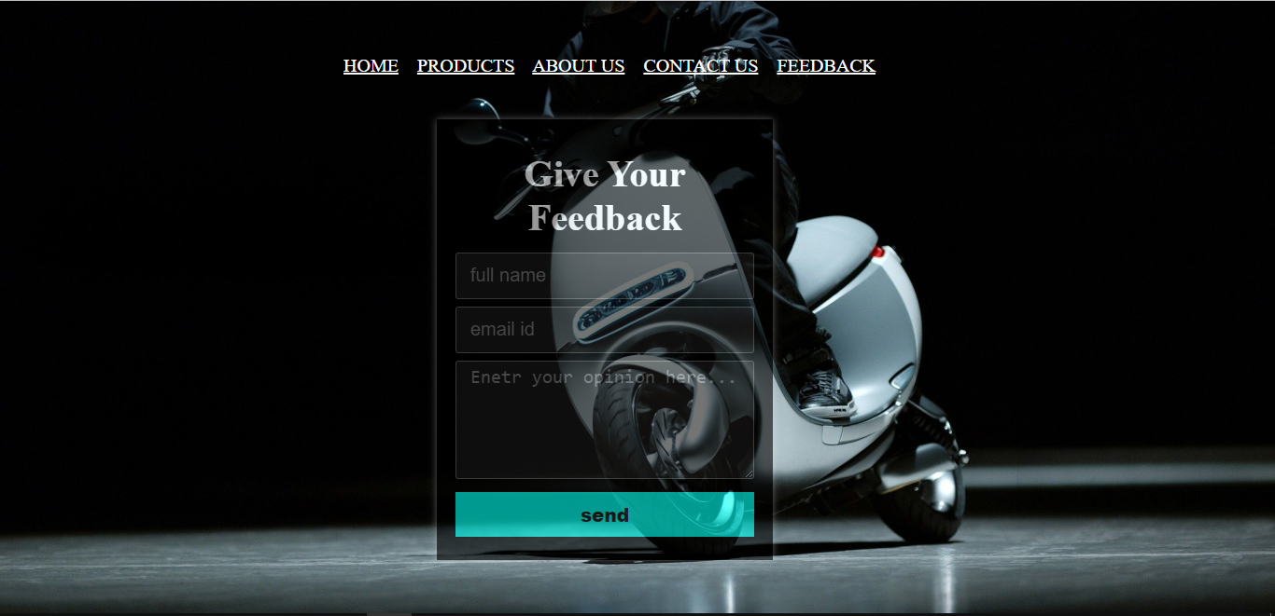

|  |
| --- |
| **Chapter 8** |
| |  | | --- | | **SPN E-BIKES** | |

**Conclusion**

The project entitled website for SPN E –BIKES was completed successfully.

This project provided us the information about the use and need of the

E-bikes and future scope of that in accordance with the the generation growing.

The project helped us in gaining valuable knowledge on several topics like designing a web page using html also the project helped us to understanding about the phase of the project and software development life cycle.

|  |
| --- |
| **Chapter 9** |
| **SPN E-BIKES** |

**BIBILOGRAPHY**

**Book:-**

1. HTML & Web Design Tips & Techniques

-Kris Jamsa Ph.D., MBA

1. CSS and HTML Web Design

-Craig Granell

**Sites:-**

[www.wikipedia.com](http://www.wikipedia.com)

[www.htmlcodetutorial.com](http://www.htmlcodetutorial.com)

[www.googlefount.com](http://www.googlefount.com)

`````````````````````````````````